# **CAPSTONE PROJECT**

# Team-1

(Sukrati Pandit, Sikta Sharma, Sukanya Sahay, Harikrishna R, Pothula Yamini)

# SQL queries

**1. Average number of items per order - daily, weekly, monthly, city, , state, pincode**

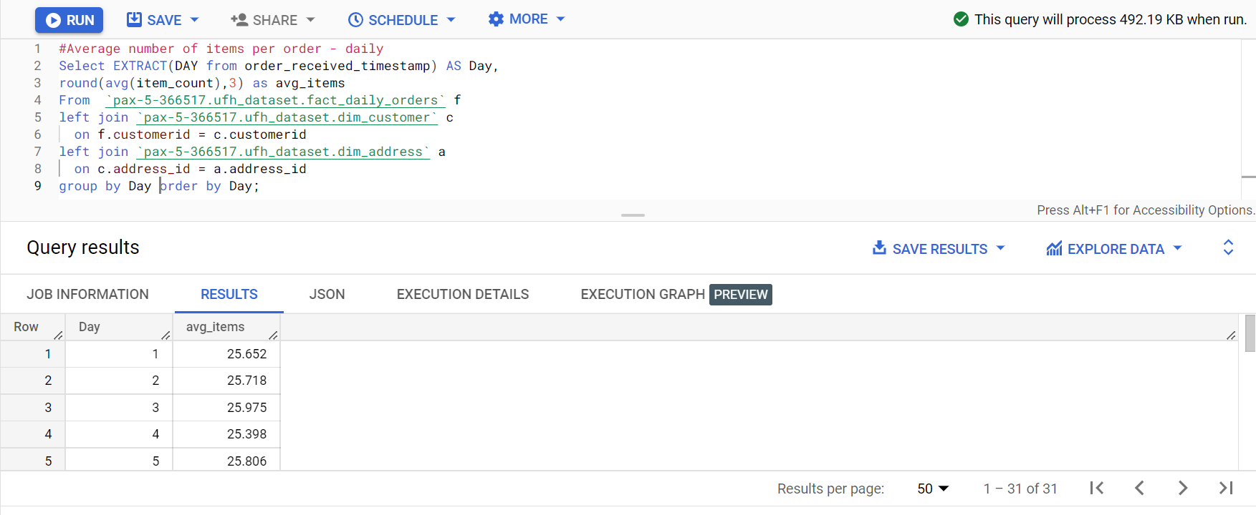

Link- [Average number of items per order - daily.xlsx](https://fractalanalytic-my.sharepoint.com/:x:/g/personal/pothula_yamini_fractal_ai/ERtDBPAMdcFCoDRTGgAMGKsBAdk9ocMcbo0fk0AAmIH-QQ?e=C0LYNb)

Link- [Average number of items per order - weekly.xlsx](https://fractalanalytic-my.sharepoint.com/:x:/g/personal/pothula_yamini_fractal_ai/EcIPpba_NyBLiOb9yUnm2RwB9Fp-fIWYrizUoOz0XJkcOg?e=3DLiEZ)

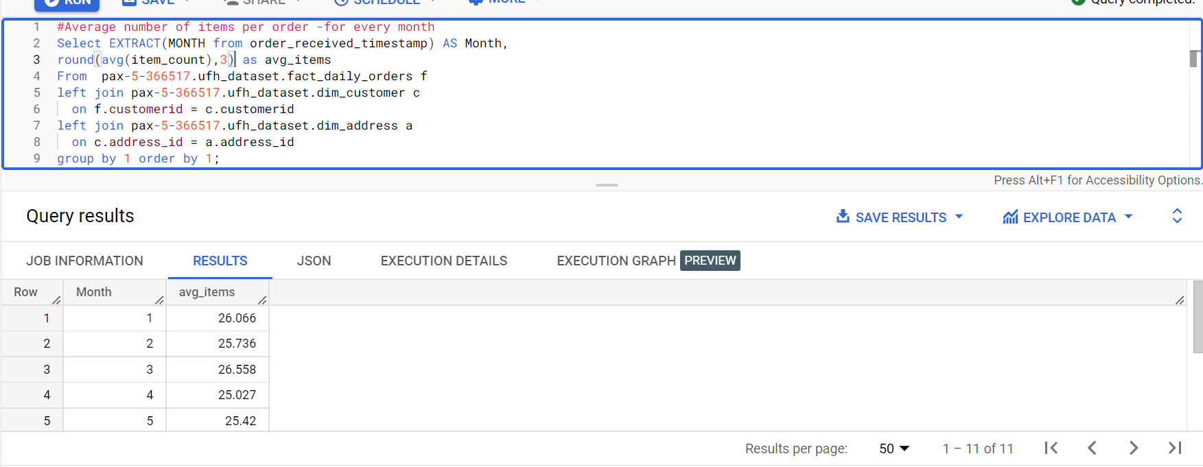

Link- [Average number of items per order -for every month.xlsx](https://fractalanalytic-my.sharepoint.com/:x:/g/personal/pothula_yamini_fractal_ai/ETdQ3JSycZ1FiD1jP3ePt4QBloAS1snwxj-_jmBc5keF6g?e=IrrFPT)

Link- [Average number of items per order -per city.xlsx](https://fractalanalytic-my.sharepoint.com/:x:/g/personal/pothula_yamini_fractal_ai/ERwai9kZ3gBPjnczjhE8yLMBC413l7QLXwwMeW9_Rj43ow?e=Oasgbn)

Link- [Average number of items per order - per state.xlsx](https://fractalanalytic-my.sharepoint.com/:x:/g/personal/pothula_yamini_fractal_ai/ES6XuPsD2sRJi4ppPlkqZ4EBiHD5-O_HT0L25_iODb9GjA?e=1ib5hm)

**2. Average amount of sales per order - daily, monthly, weekly, state, city, pincode**

#Average amount of sales per order -  daily

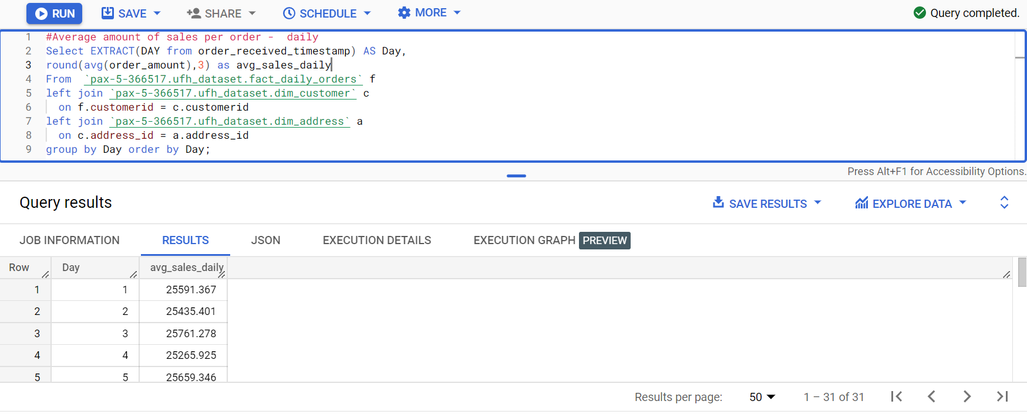

#Average amount of sales per order - weekly

#Average number of items per order -per city

#Average number of items per order - per state

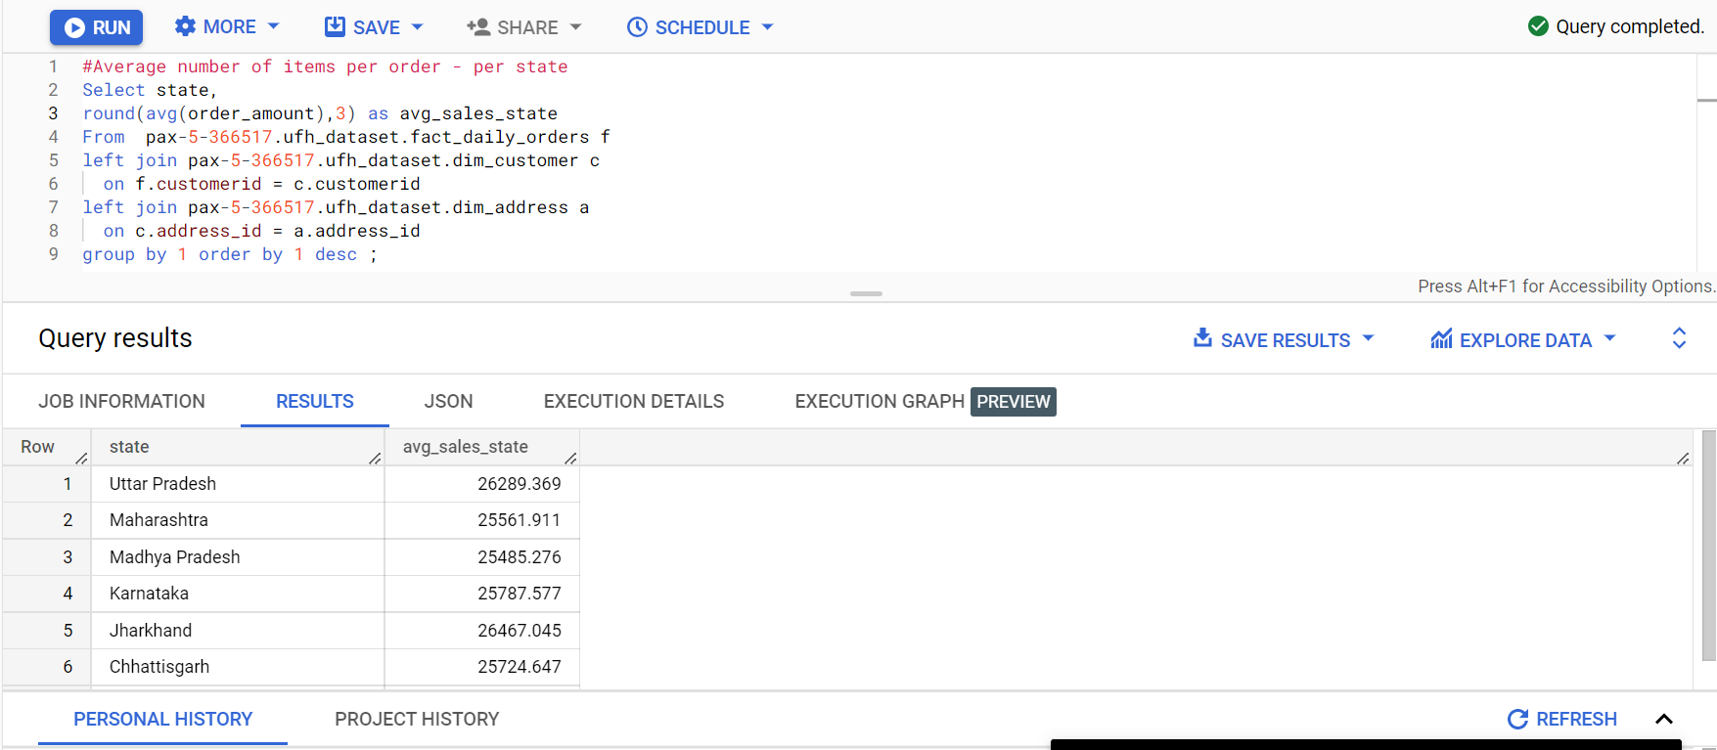

**3. total number of units sold per day of a product SKU and its monthly trend**

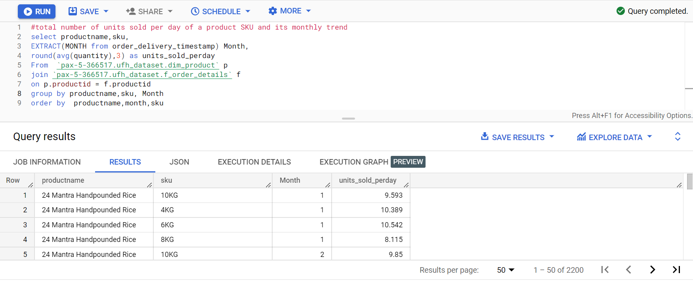

Link- [total number of units sold per day of a product SKU and its monthly trend.xlsx](https://fractalanalytic-my.sharepoint.com/:x:/g/personal/pothula_yamini_fractal_ai/EUAAPes4h8FJntAlSyXfw5IBQnCYSHMdua22-7jRud_xDg?e=KtyzEe)

**4.** Total Order Amount on daily basis, also to be able to split by product and geography

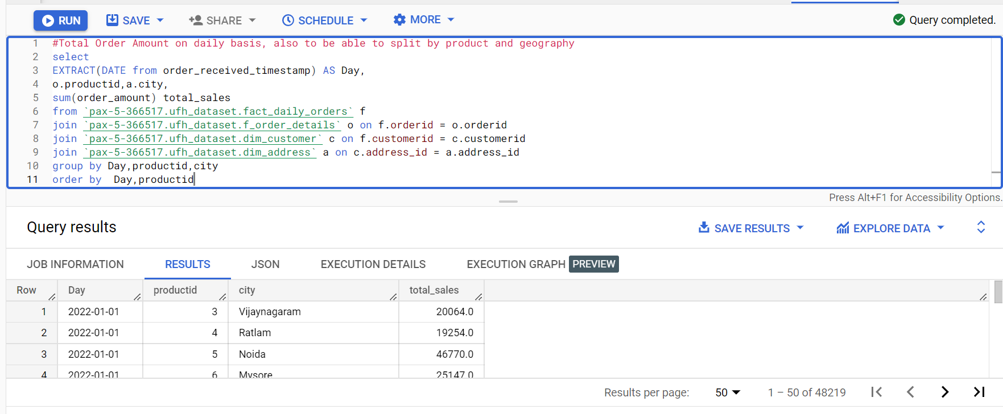

Link- [Total Order Amount on daily basis, also to be able to split by product and geography.xlsx](https://fractalanalytic-my.sharepoint.com/:x:/g/personal/pothula_yamini_fractal_ai/Eag27qFmFIpPuOqpTye8Z9oBRVM_EBdS3EAL8cJDjPk-2A?e=c4aVHW)

**5.** Distribution of orders according to area ( state, city, pincode etc)

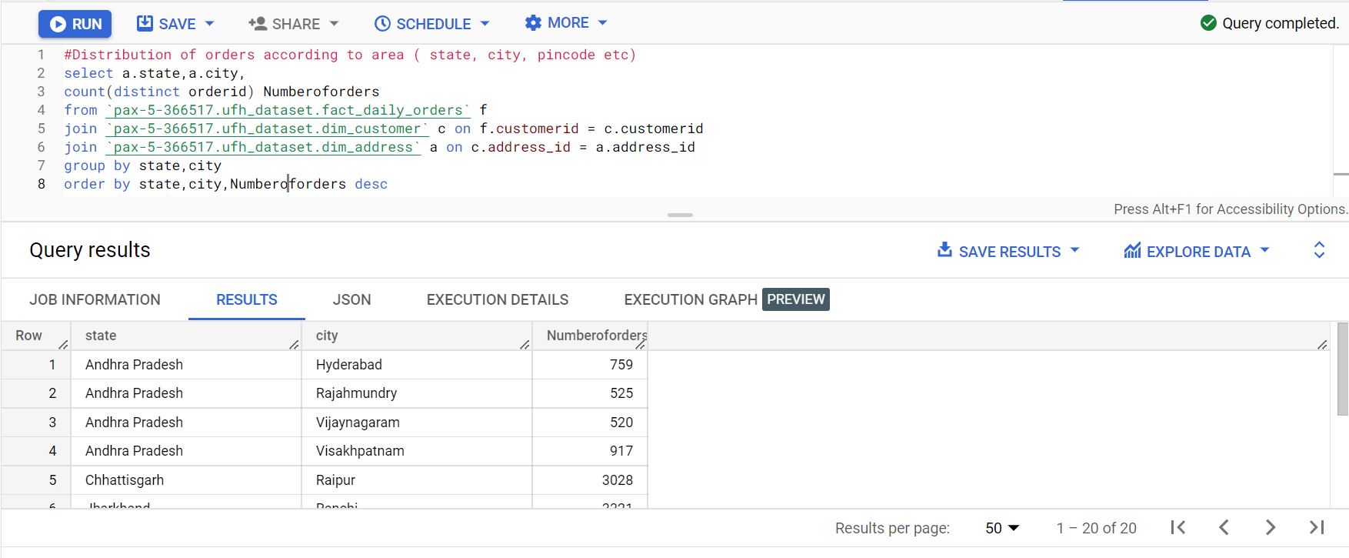

Link- [Distribution of orders according to area ( state, city, pincode etc).xlsx](https://fractalanalytic-my.sharepoint.com/:x:/g/personal/pothula_yamini_fractal_ai/EeV82OwrX8hMnKrwaLrJvRcB7I4cT850LNp_OMe-8v7Lug?e=MnYEUR)

**7.** New Customers on daily basis

**8. Total count of customers everyday**

**9. Average time to delivery order. Min and Max time. To be able to slice and dice on hour, weekday, weekend, daily, monthly, geography**

Link- [Average time to deliver order..xlsx](https://fractalanalytic-my.sharepoint.com/:x:/g/personal/pothula_yamini_fractal_ai/EWQICQifnv1KuH437Ut_hqIBZettN8TSMQcPdDcRvAkODw?e=qvTLYD)

**10. Total orders : to be able to slice and dice on hour, weekday, weekend, daily, monthly, geography**



